This the second of three posts related to setting up an Active Directory domain within a network of VMs. In the original post, which can be found here, <https://github.com/krismage/posts>, we set up the Active Directory Domain Services (AD), the Domain Name Services (DNS), and Dynamic Host Configuration Protocol (DHCP) on our primary Windows 2019 Server. In this post, we are going to add a secondary domain server to the domain and add our first host, a Windows 10 system.

Before getting started, we need to look at our hypervisor network settings on all three machines. I’m using Oracle’s VirtualBox, but regardless of what hypervisor is being used, you need to insure that all three systems are set to the same network settings. For my environment, I’ve set them all to the same internal network. I’ve done this instead of NAT or bridged to insure that there wouldn’t be any DHCP conflicts.

We’ll start by booting up our primary AD server. We just want to make sure it’s up and running and all the necessary services are running. After that, we’ll boot up the secondary Windows Server. I’ve previously changed the name of the server to something more readable and assigned it a static IP address, so if you haven’t done that, those should be the first things that you do.

After booting up the secondary server, I do a quick check of network connectivity by pinging the primary server from the secondary to insure that the two servers can communicate with each other. Now we’re ready to add Active Directory Domain Services to the secondary server. Starting with the Server Manager open, we go to manage in the upper right hand corner.

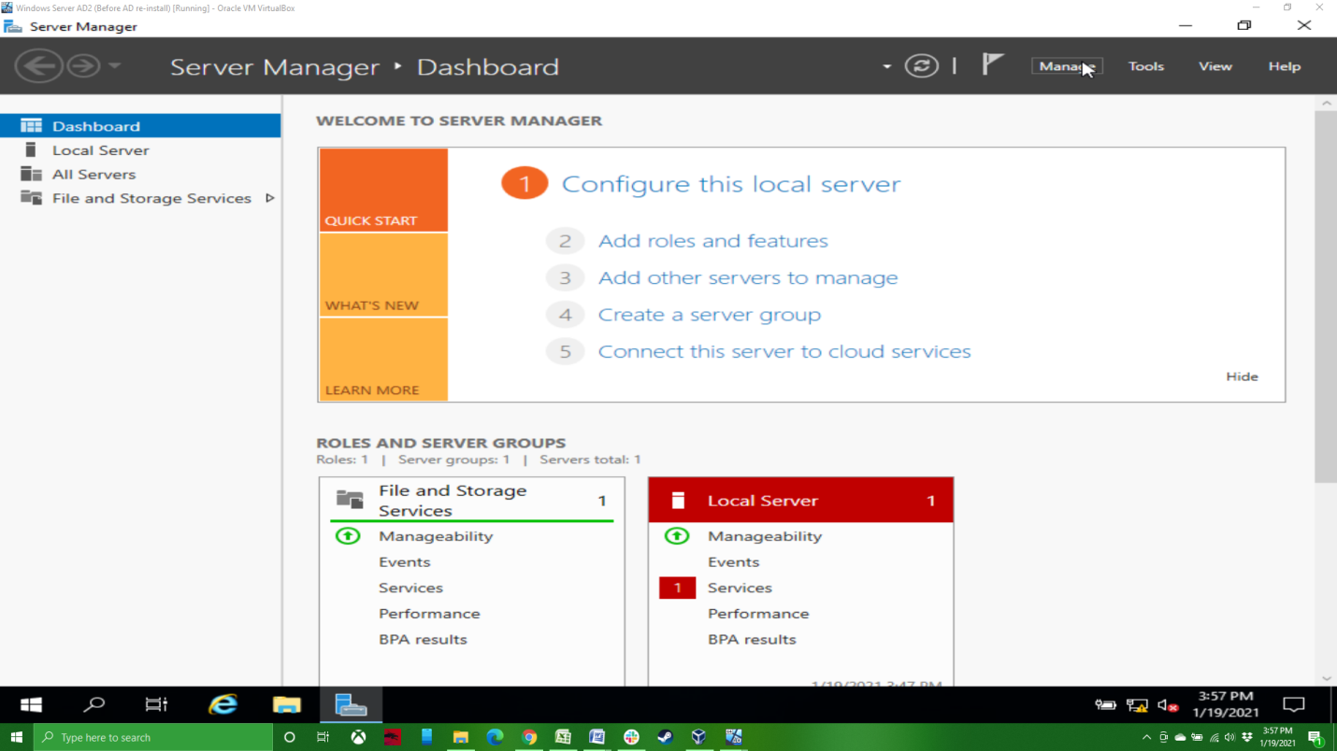

We then want to Add Roles and Features, as we did before.

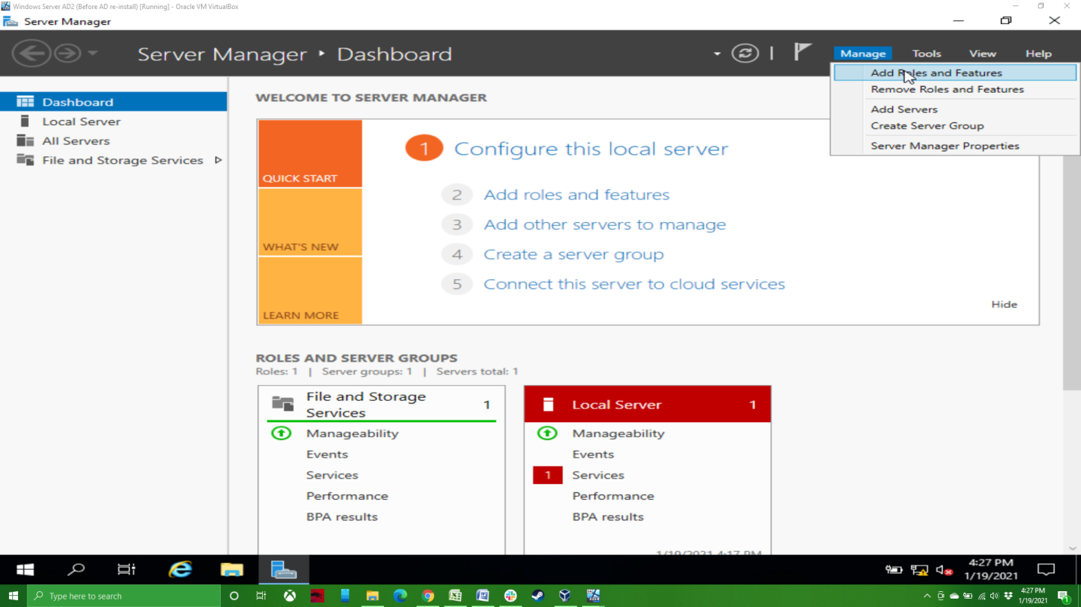

Click Next on the first screen, this is a Role-based installation, so click Next.

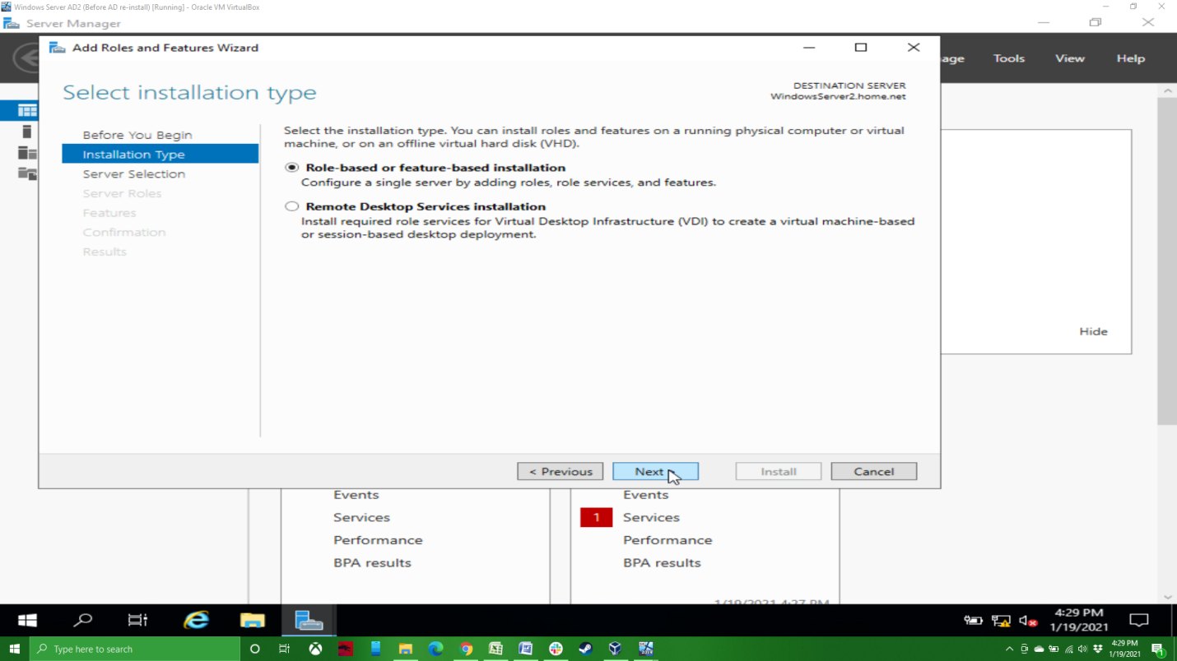

Make sure you have the correct server selected. In my case I only have one choice, which is the one I want. Click Next.

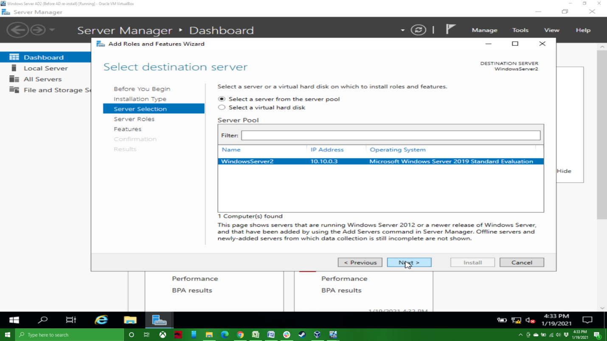

On the Server Roles screen, you’ll want to click the box next to Active Directory Domain Services. This will bring up a pop up asking if you want to add the feature; click Add Feature and then click next.

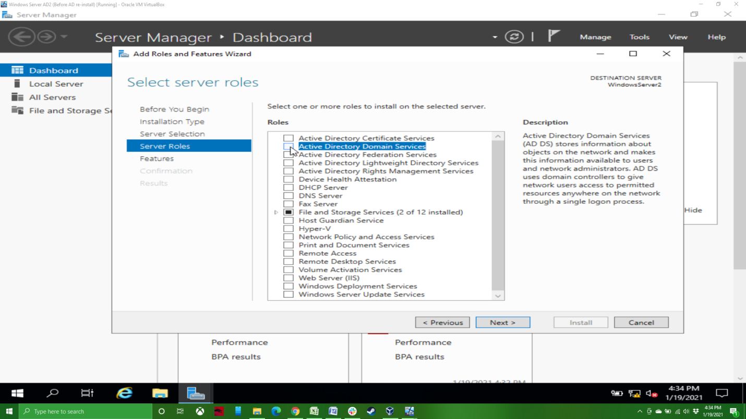

On the Features and AD DS screens you can just click Next. This will bring you to the Confirmation screen, where you can just click Install. If you want, you can click the box to automatically restart the computer in required.

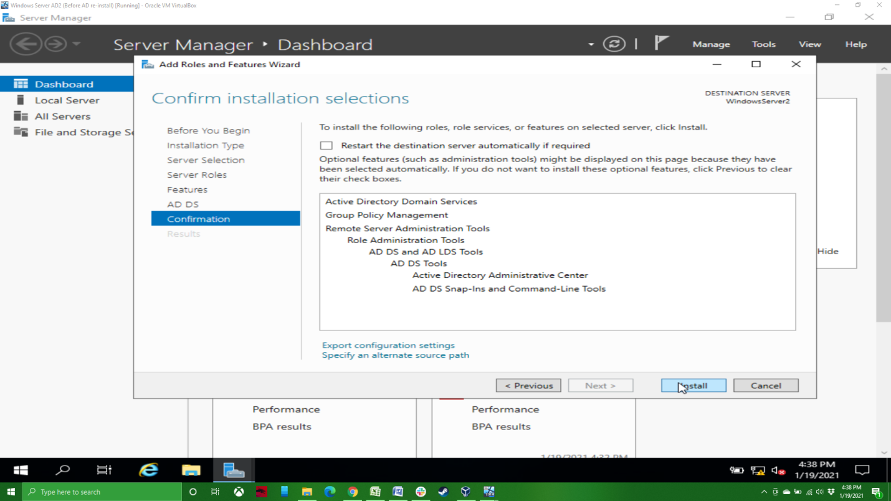

The installation doesn’t take too long, but feel free to walk away for a bit if you want. After this, we’re going to need to promote the server to a domain controller.

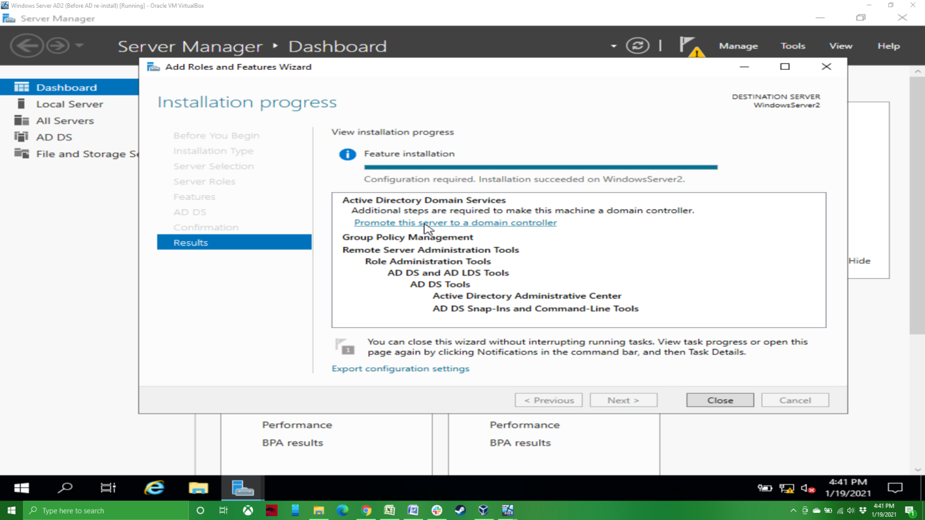

On the Deployment Configuration screen, we’re going to leave Add a domain controller to an existing domain checked, we’re going to put the name of our domain in the domain name field, and then click on Select… This will pop up an authentication screen, where you’ll want to put in an administrative user name and password for the domain. Remember that you’ll need to use the domain’s administrative account, not that of this server.

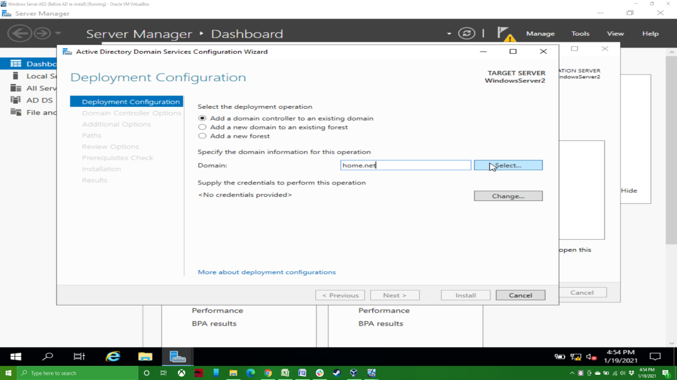

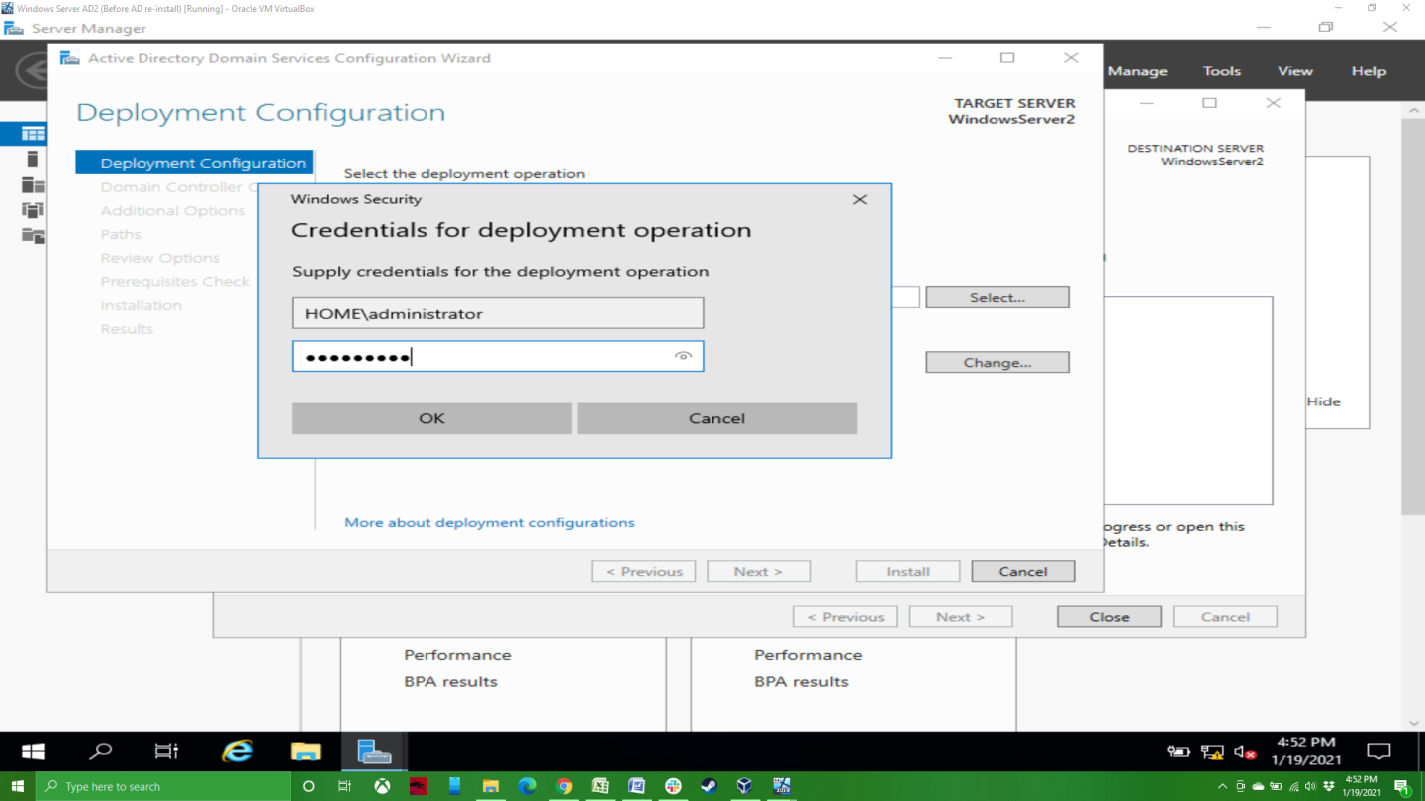

After inputting this, you’ll want to select your domain and click OK.

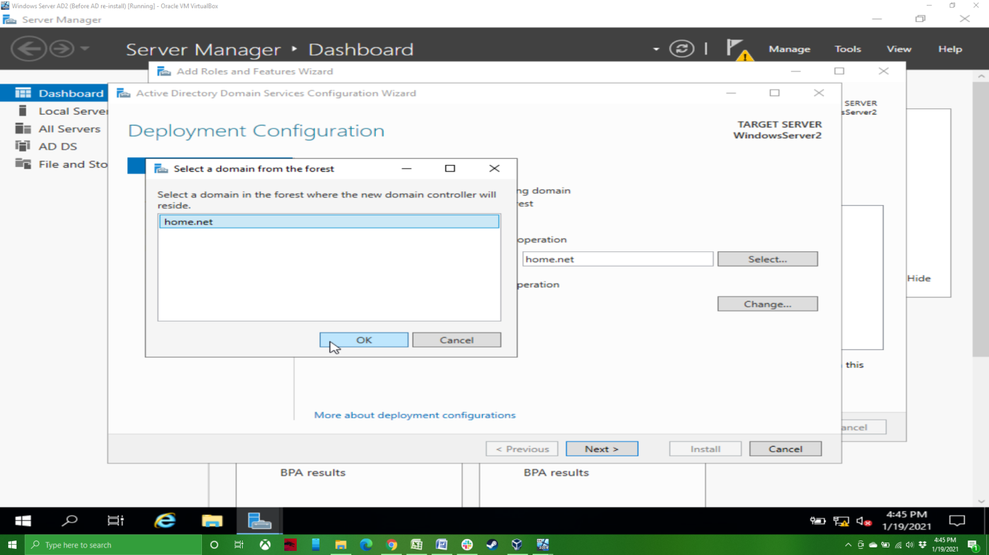

You can then click Next to get to the options screen.

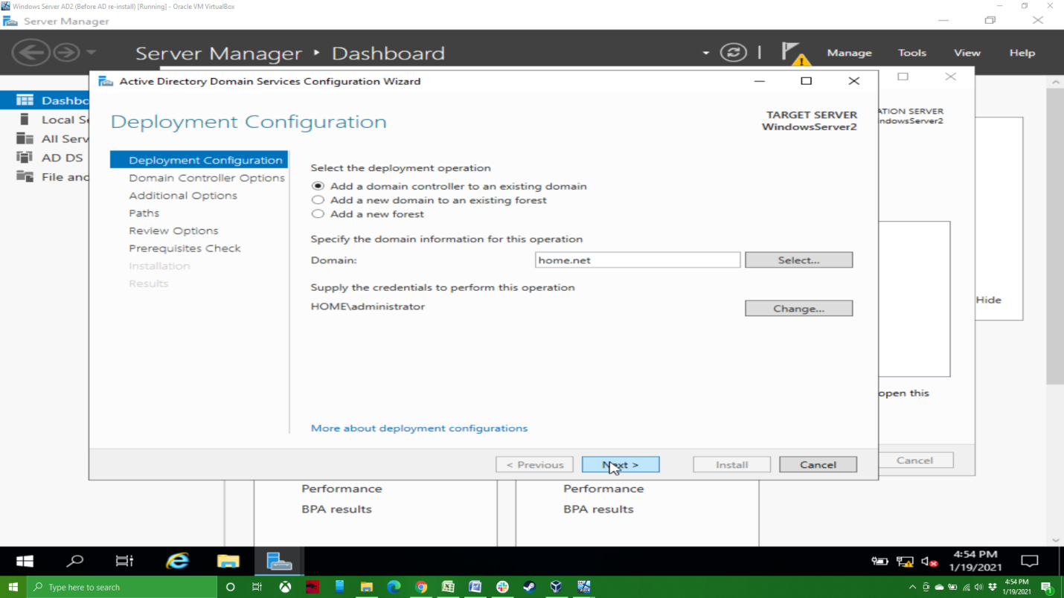

Here you want to add a Restore Mode password.

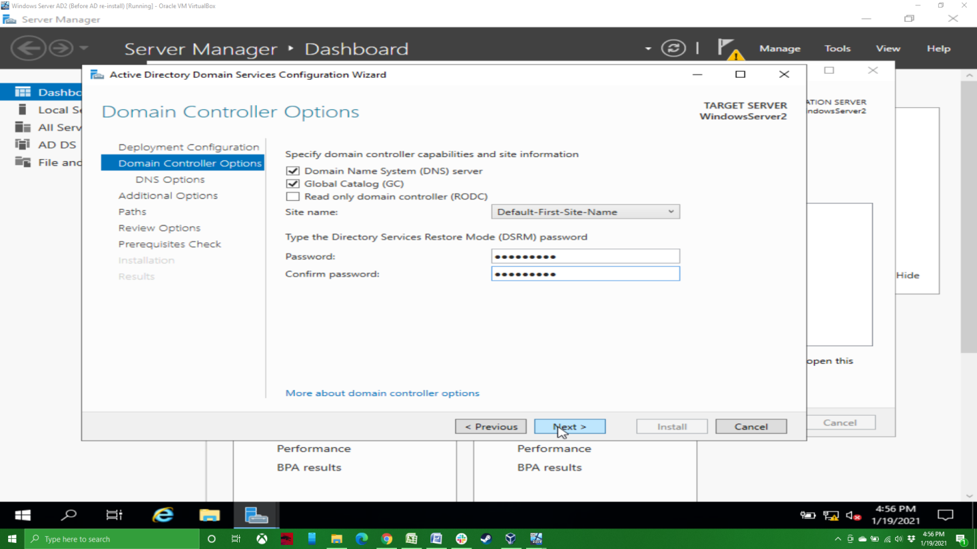

You can leave the Domain Name System (DNS) server box checked if you want to use the server as a secondary DNS server as well. I’ve unchecked the box for this exercise.

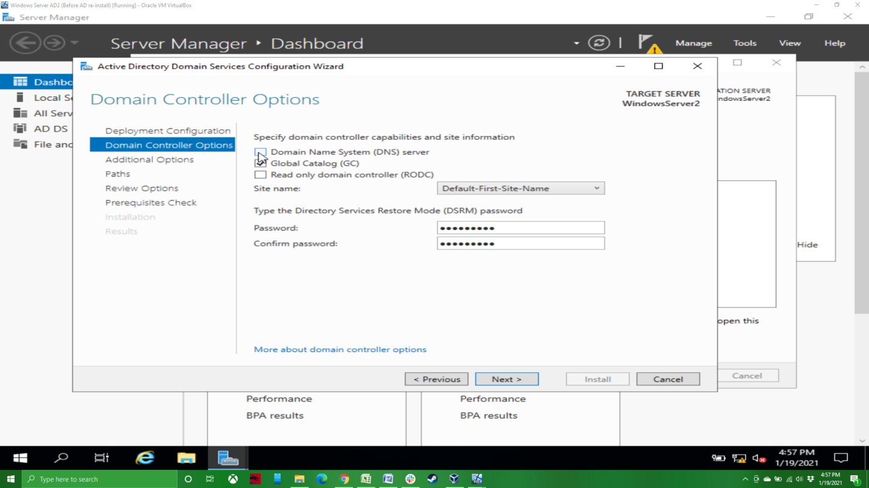

Under Additional Options, you can choose your replication options. My options were any domain controller, or my primary domain controller. I chose my primary.

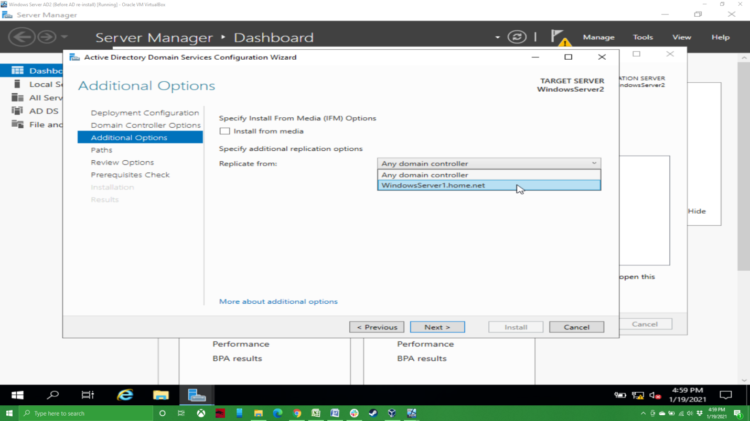

On the Paths and Review Options screens, you can just click Next. Assuming your prerequisites check checks out fine, you click on Install. After you do, the computer will do the installation and then restart the server.

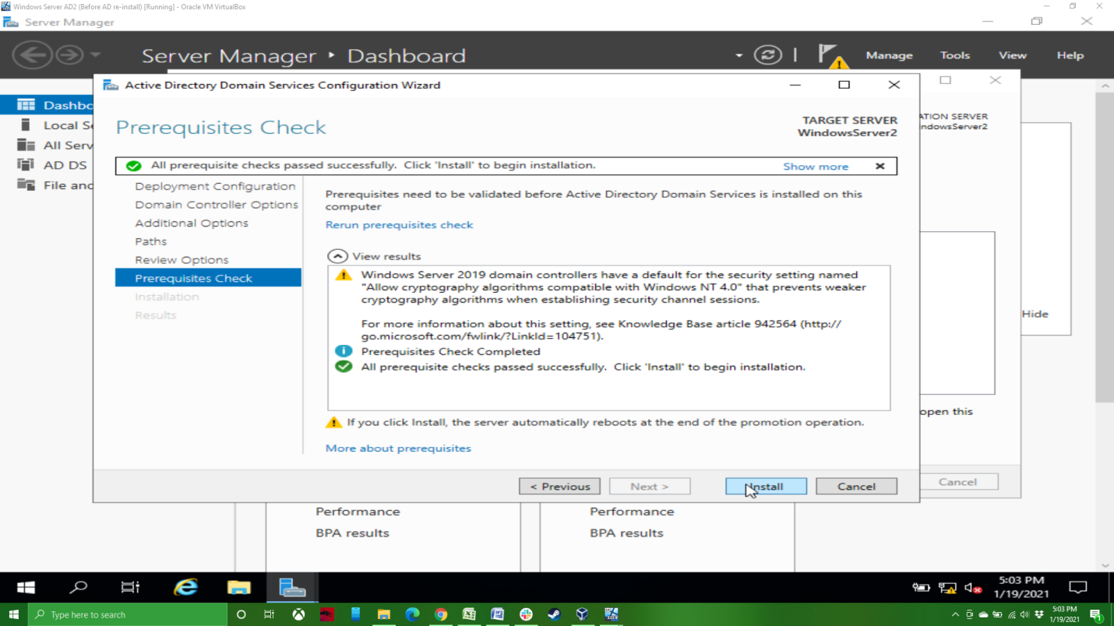

After the computer restarts and you go to login again, you should see that you are now part of the domain.

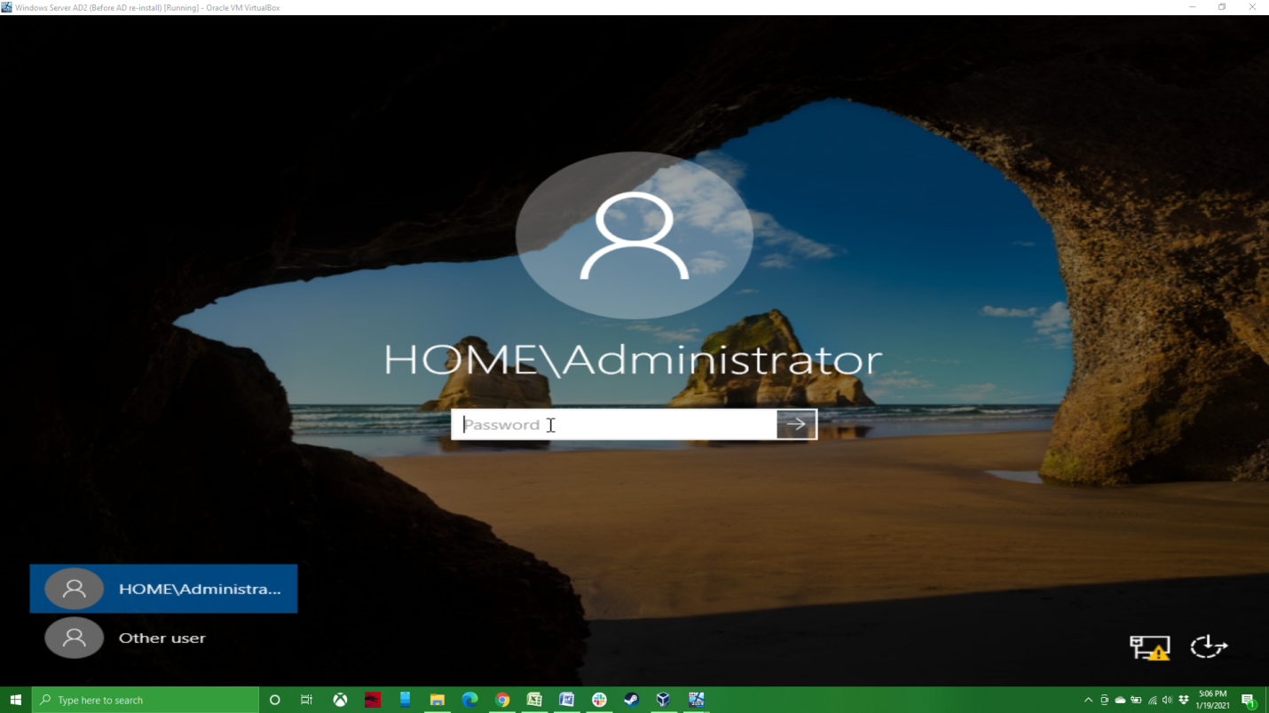

After logging in, you’ll now see that the AD DS is running on the server.

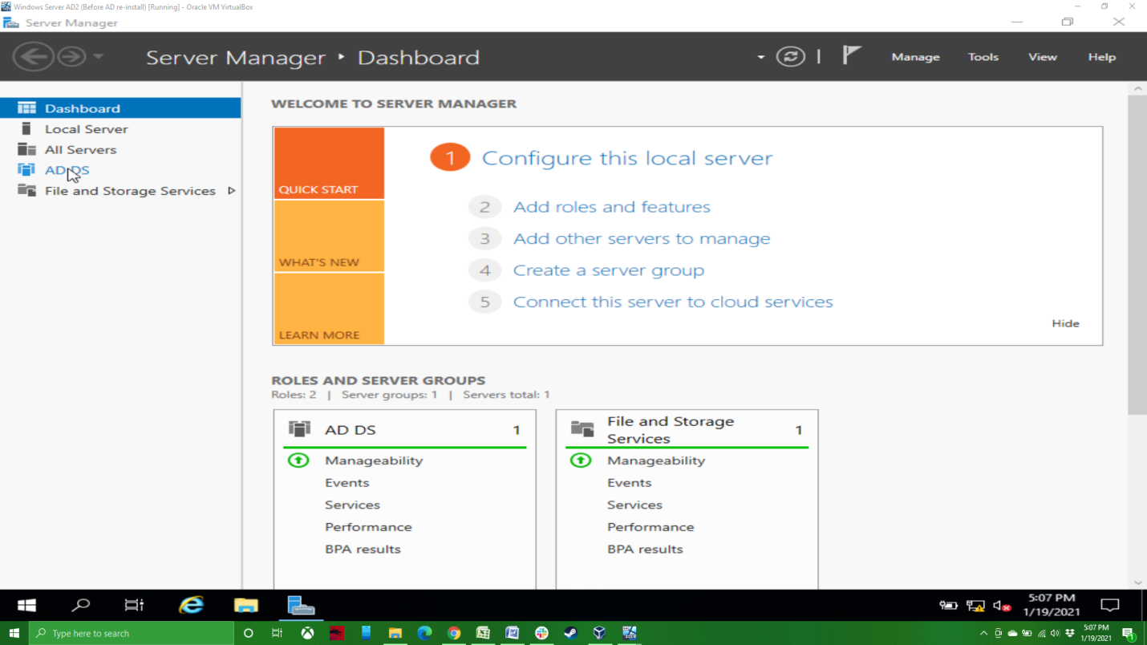

And if you go look at System Properties, you’ll notice that the Full computer name and Domain have changed.

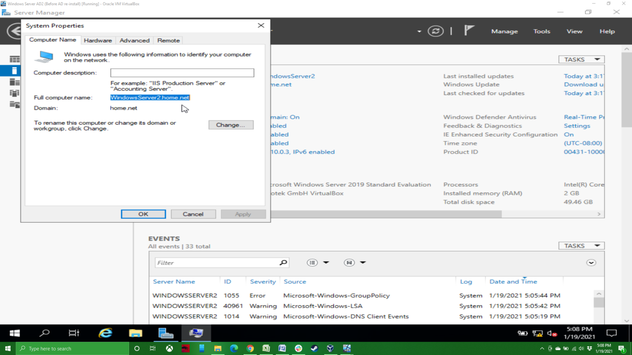

Finally, from either server, if you go to Tools in the upper right hand corner…

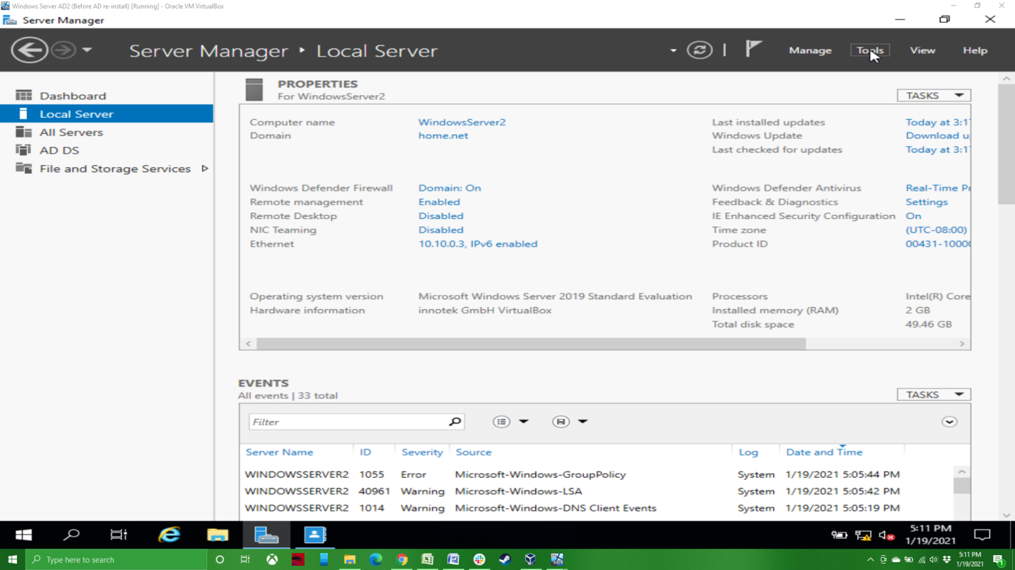

…and open the Active Directory Administrative Center, we can check to see if both servers are in the domain.

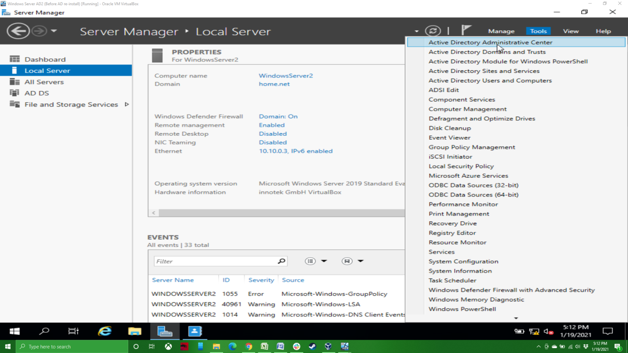

If you click on Domain Controllers under home (local), you’ll see both servers listed as domain controllers. With that, we’re done adding our secondary domain controller and can turn to adding our first host to the domain.

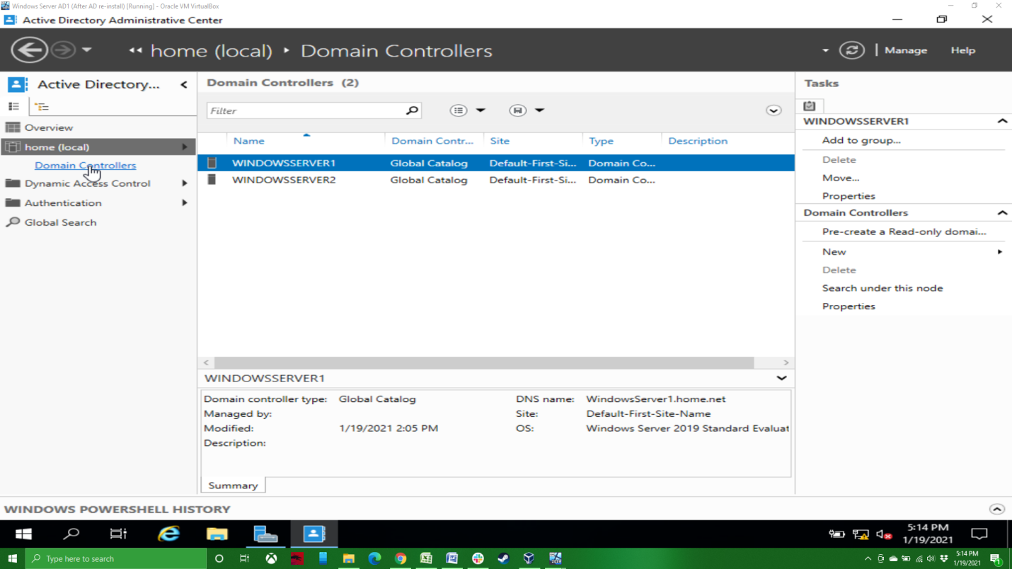

With at least the primary domain controller running, we’ll boot up our Windows 10 system. When you first go to log in, you’ll notice that you are not part of the domain.

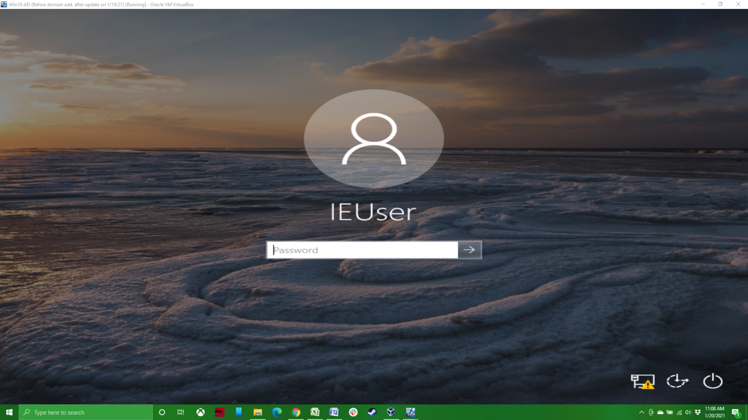

The first thing I like to do is check to make sure my system and the server can communicate with a simple ping of the server. The Windows 10 system should have received its IP address from the DHCP server. Next, if you haven’t already, you should go to the System Properties and change your computer’s name. You can see that I’ve already named my system Win1001. You’ll also note that it is currently part of a Workgroup and not a Domain. Let’s change that.

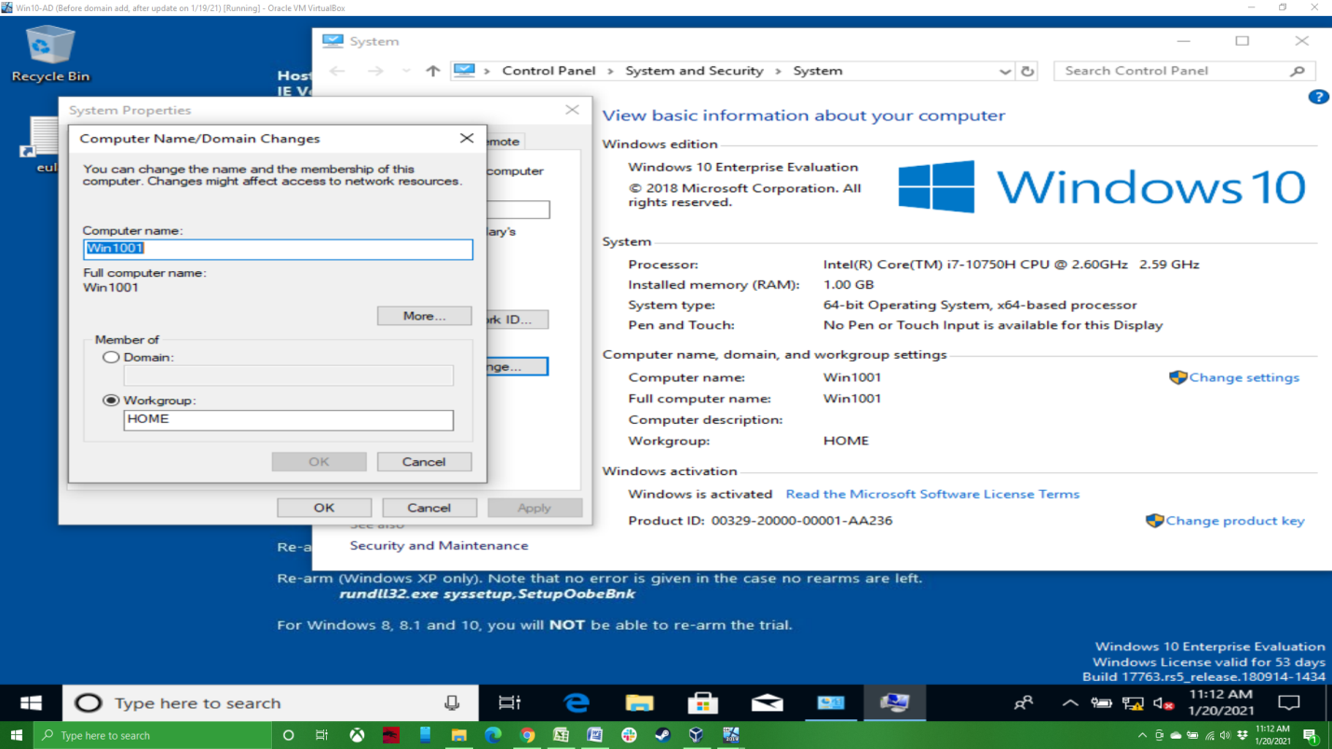

On the same screen where you change the computer’s name, you need to click on Domain and add the name of the domain in the field.

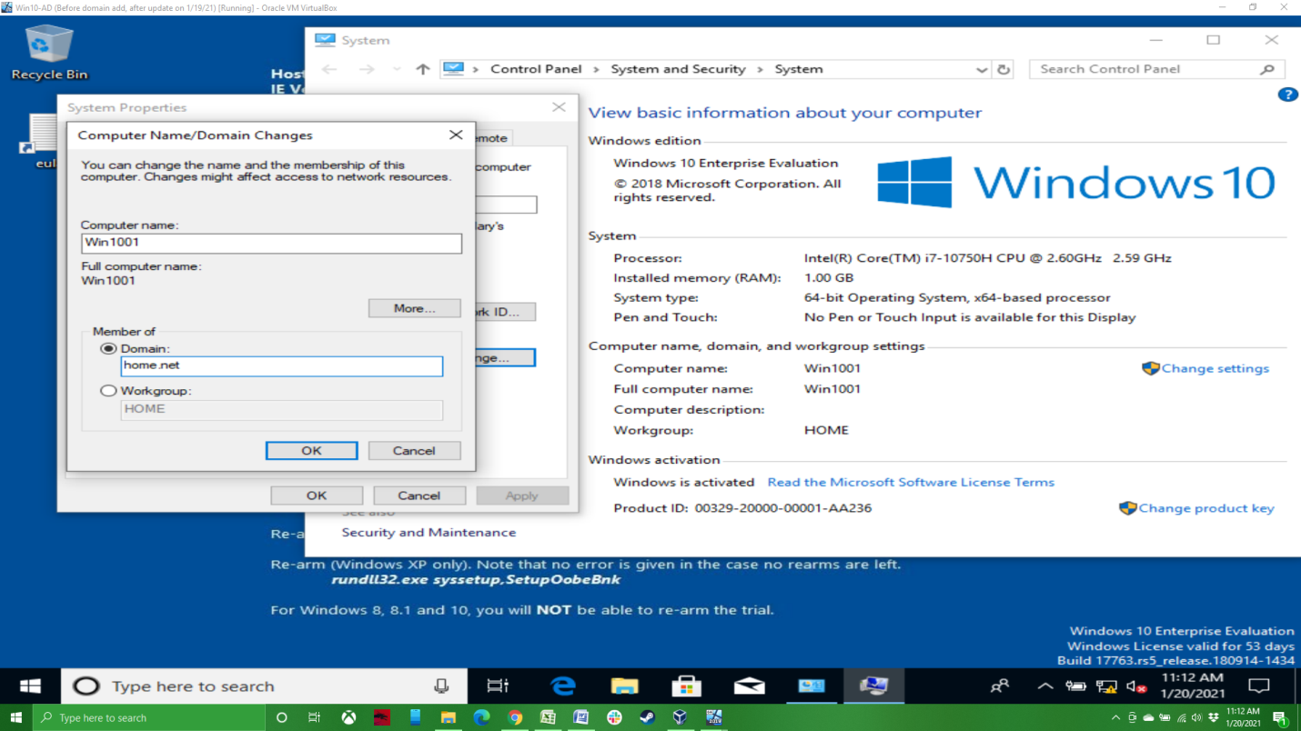

You will be prompted for a user name and password for a domain administrator. After entering the necessary credentials and clicking ok, you should have a welcome to the domain message pop up on the screen. It can take a few moments for the welcome message to pop up. After clicking OK, you will be prompted to restart the computer. Do so.

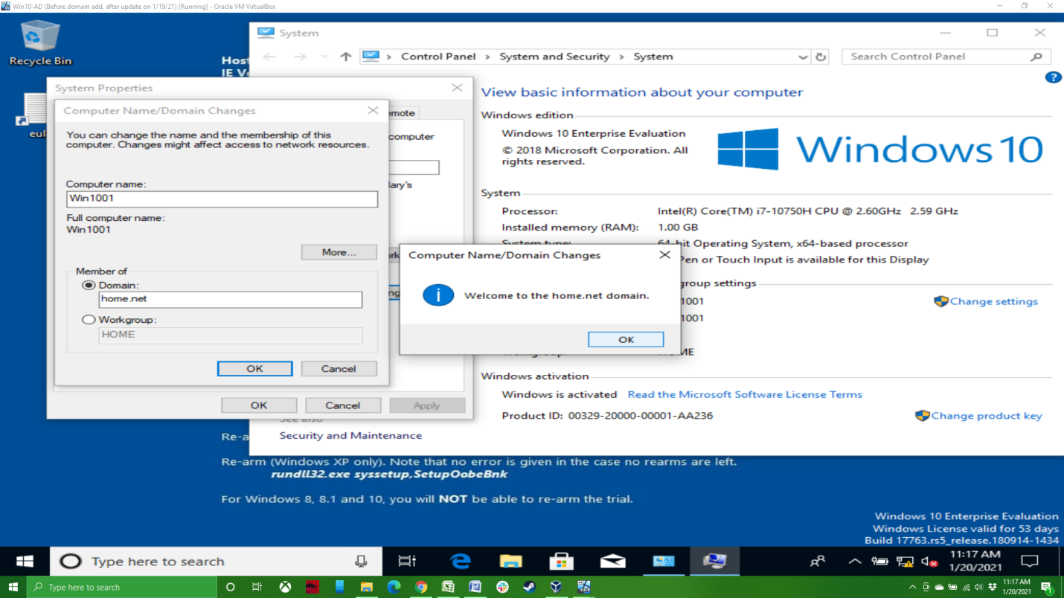

After the computer has restarted, you’ll need to change the user to log into the domain. I used my domain administrator account, since I haven’t yet created any other accounts on the domain. After logging in, the computer will take a few moments to log in as is configures itself to be on the domain.

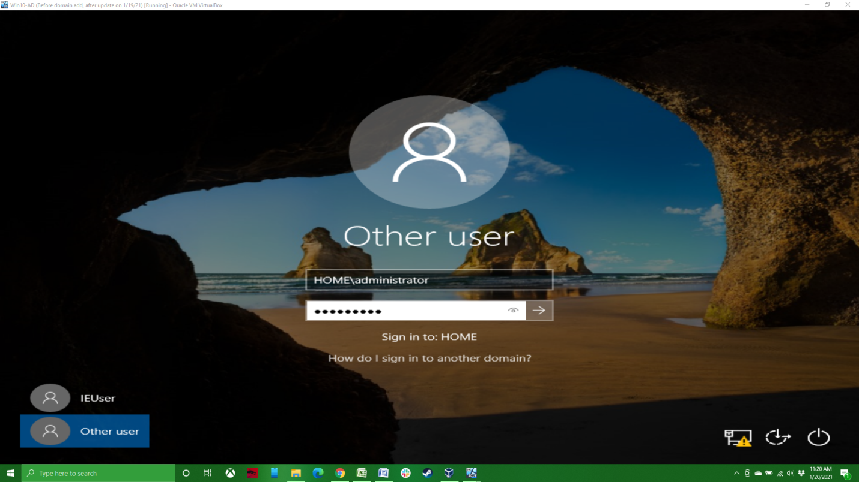

If we go back to the system screen, we’ll see that the full name of the computer has changed to include the domain, and the domain name is present.

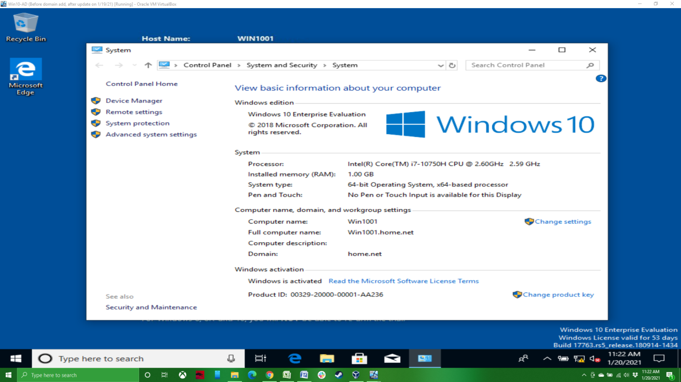

And that’s it. We’ve added a secondary domain controller and our first host to the domain. If we go back to our Windows Server and open up the Active Directory Administrative Center again, click on home (the domain) and computers, we’ll see our Windows 10 machine has been added to the domain.

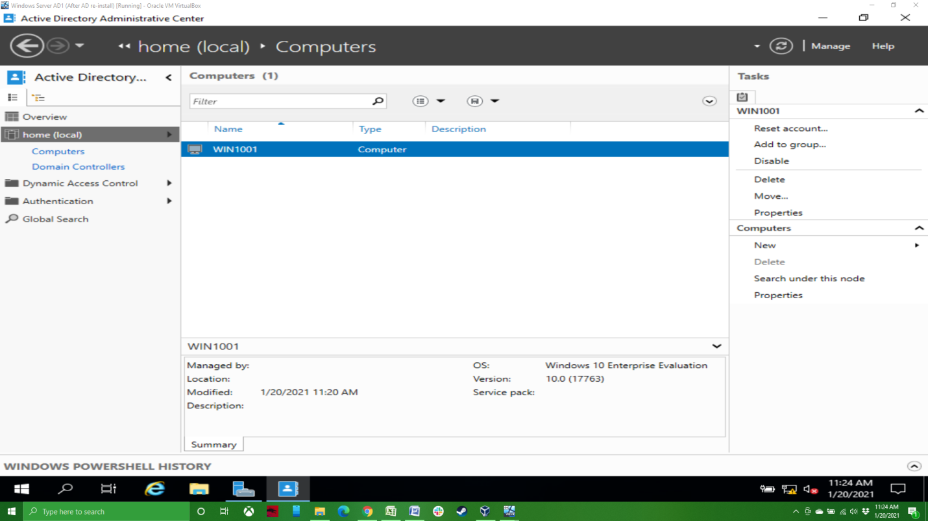

Next time, we’ll add a couple of Linux machines to the domain, and Ubuntu desktop and server.